EX:NO:11 CONFERENCE MANAGEMENT SYSTEM

USE CASE DIAGRAM:

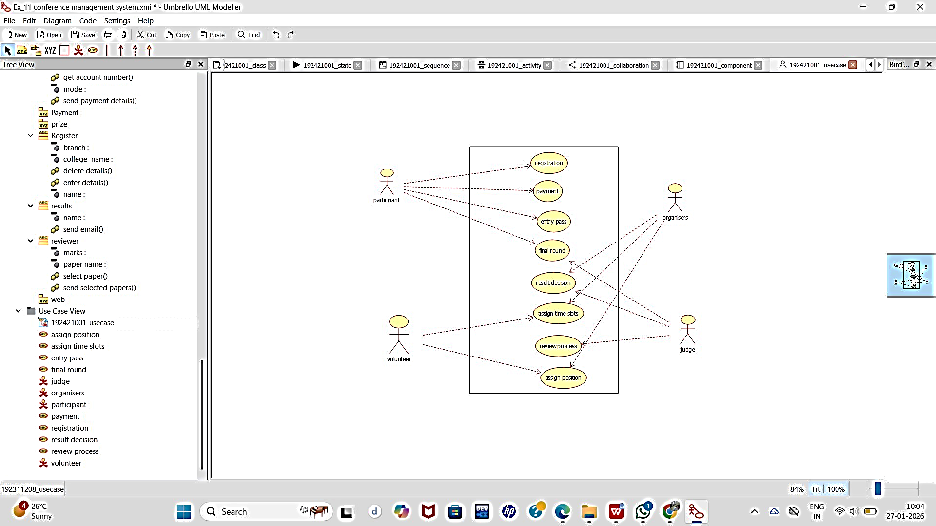

CLASS DIAGRAM:

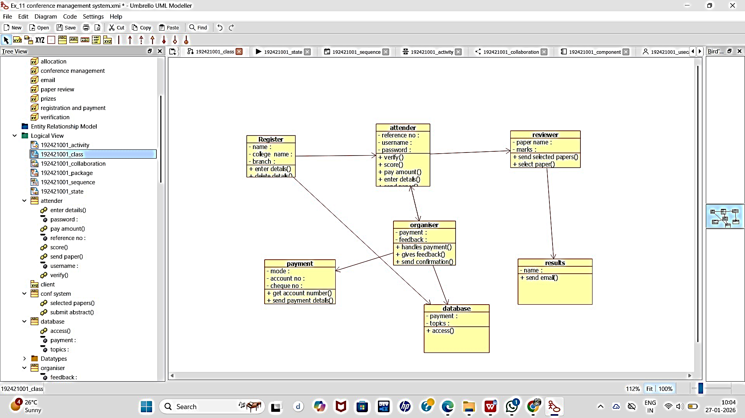

ACTIVITY DIAGRAM:

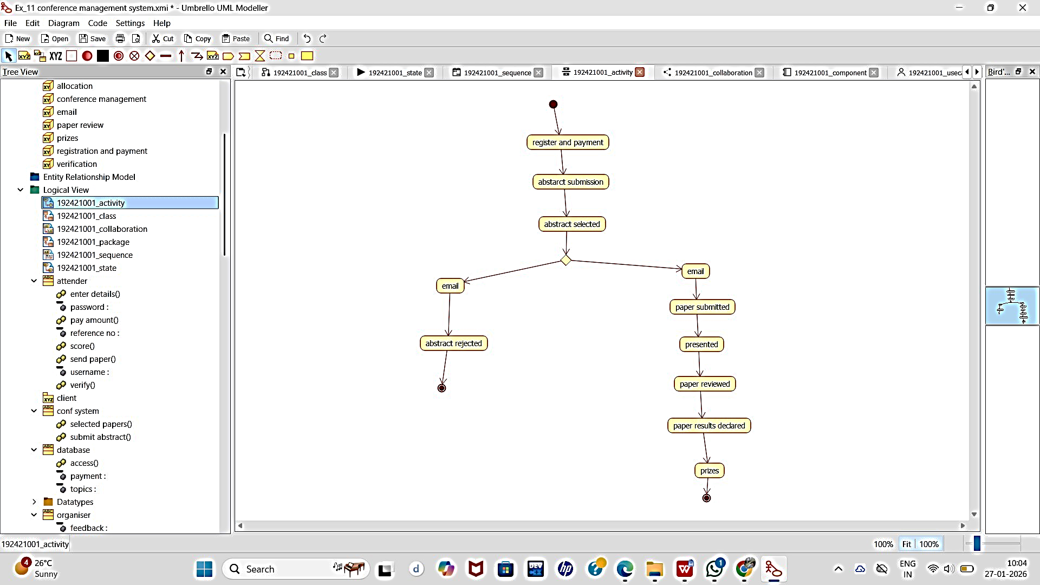

SEQUENCE DIAGRAM:
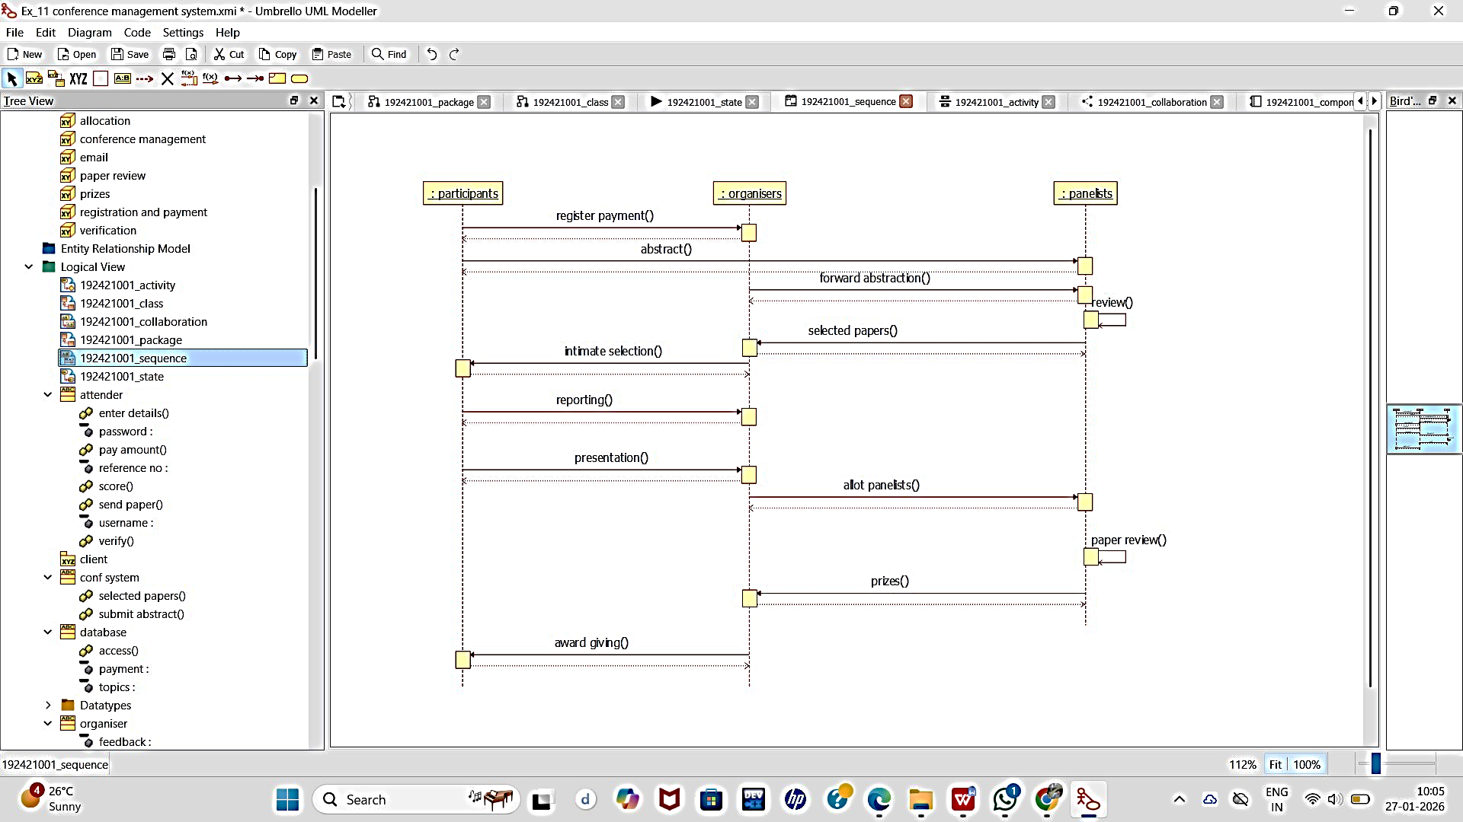

COLLABORATION DIAGRAM:

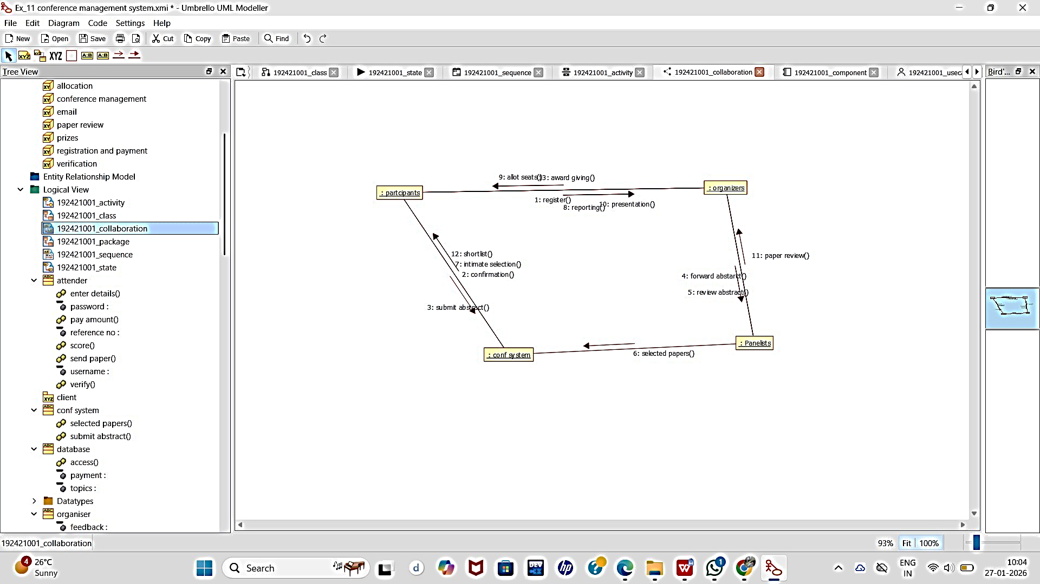

COMPONENT DIAGRAM:

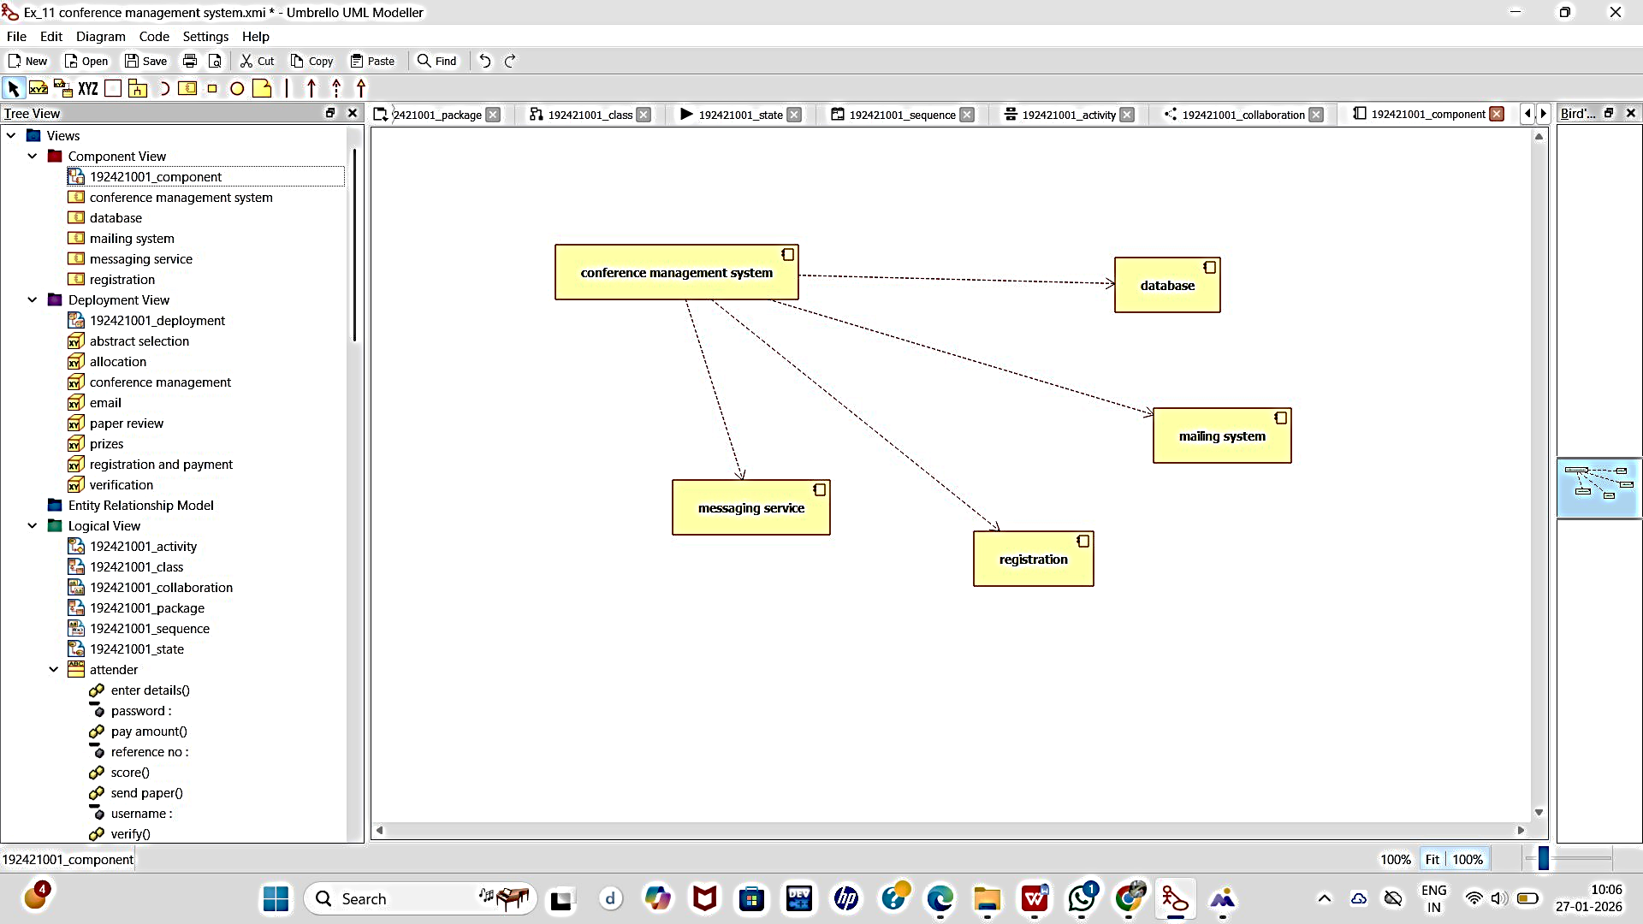

DEPLOYMENT DIAGRAM:

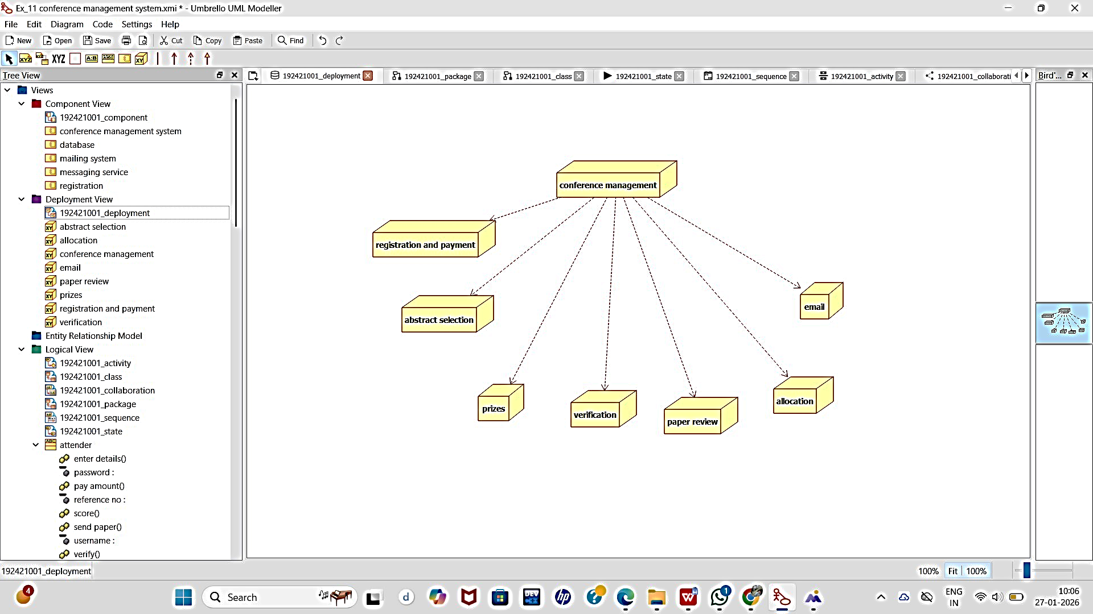

PACKAGE DIAGRAM:

